**LAB 1 - E-COMMERCE WEB APPLICATION**

Name: Dileep Kumar Durgam

Class ID - 8

Team Mate: Herbert

Class ID – 31

Team -ID: 8

OBJECTIVE: To develop an E-Commerce web application for online shopping under retail domain using HTML, CSS, BOOTSTRAP.

**Approach:**

We have several modules in our project.

Our E-commerce application or website name is “Find Styles”. Our homepage shows various items and categories. These include brand name “Find Styles”, Home, About, Cart buttons. We also have Categories like Men’ wear and Women’s wear Which are drop down menus. There is a “search” button which we can search for items. On the left we have buttons like Signup, Login, and Guest user on clicking them they will open a new window for further details. We also have cart which shows the items and total price in the cart. All these we implemented in a “Navigation Bar” and our Navigation Bar is fixed to the top.

Further on reducing the window size we get a hamburger, which include some of the buttons and items.

The next module is First page of our website, which have a background image , on which we displayed our brand name and a small caption of our brand under it we have a button “Show Now”

The next module is Login Page Which appears when we click on the login button it pops up the login page, which have the username and password blanks to write and there is a sign in button which loads into user’s account.

Next module is “Sign up” Page. It has various details like First name, Last name , gender , email and password , birthday , and a check button for agreement , then finally a submit button. The new user have to fill this form to be registered after that he can use login details to login into the page.

Final module is “products” which are present in the home page and also in the categories like men’s and women’s section. On clicking on the product, it pop up to a new window which shows the product details like a brief description of a product. It had check list for size and a text blank for quantity, and links to cart.

**Demo**: <https://youtu.be/Ol7BJBLG_v8>

**Source Code** - <https://github.com/Dileep1111/Web_Lab_Assignmen_1>

**Screen Shots:**

1. Login.

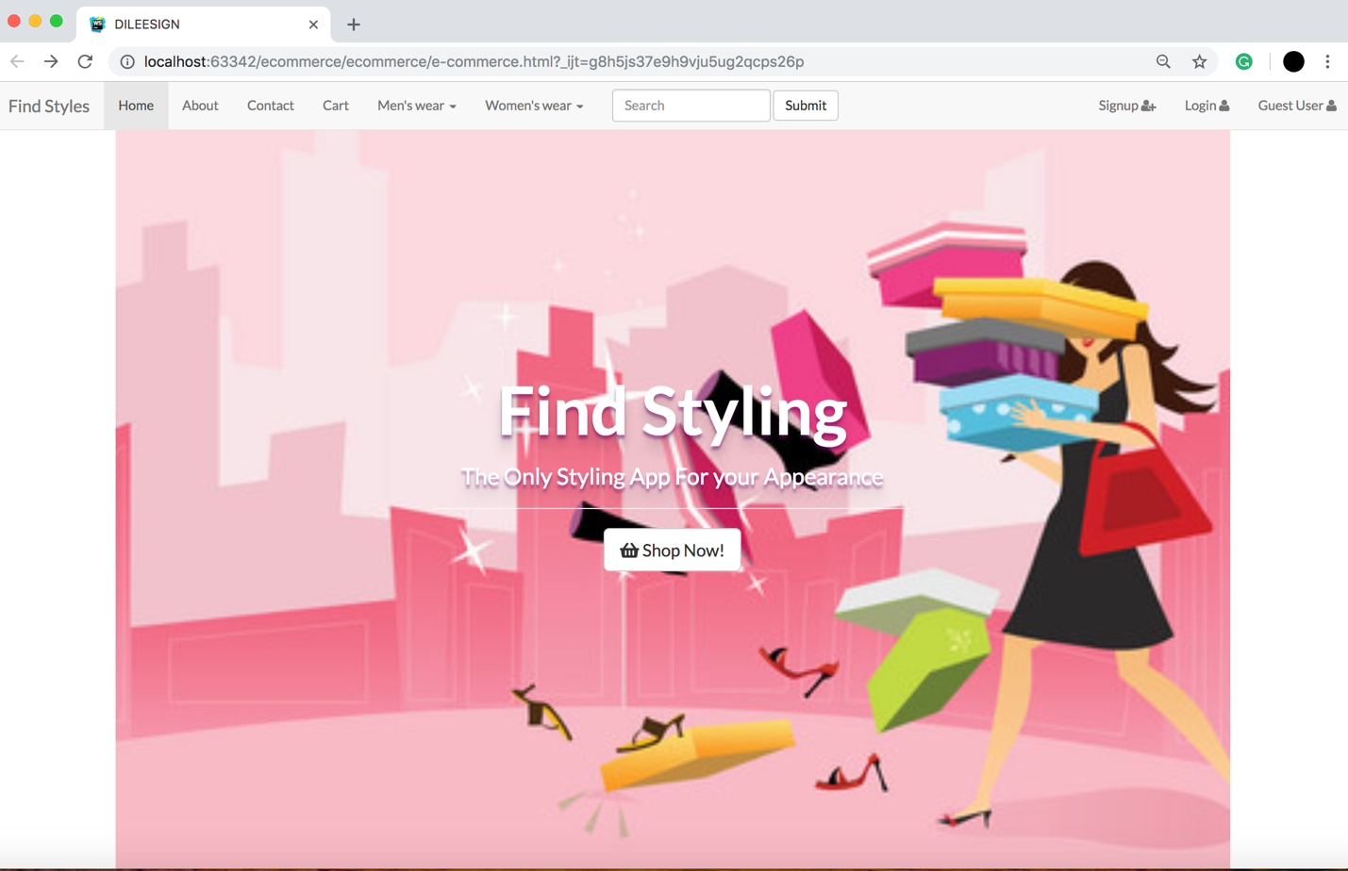

1. Responsive First page and Hamburger.

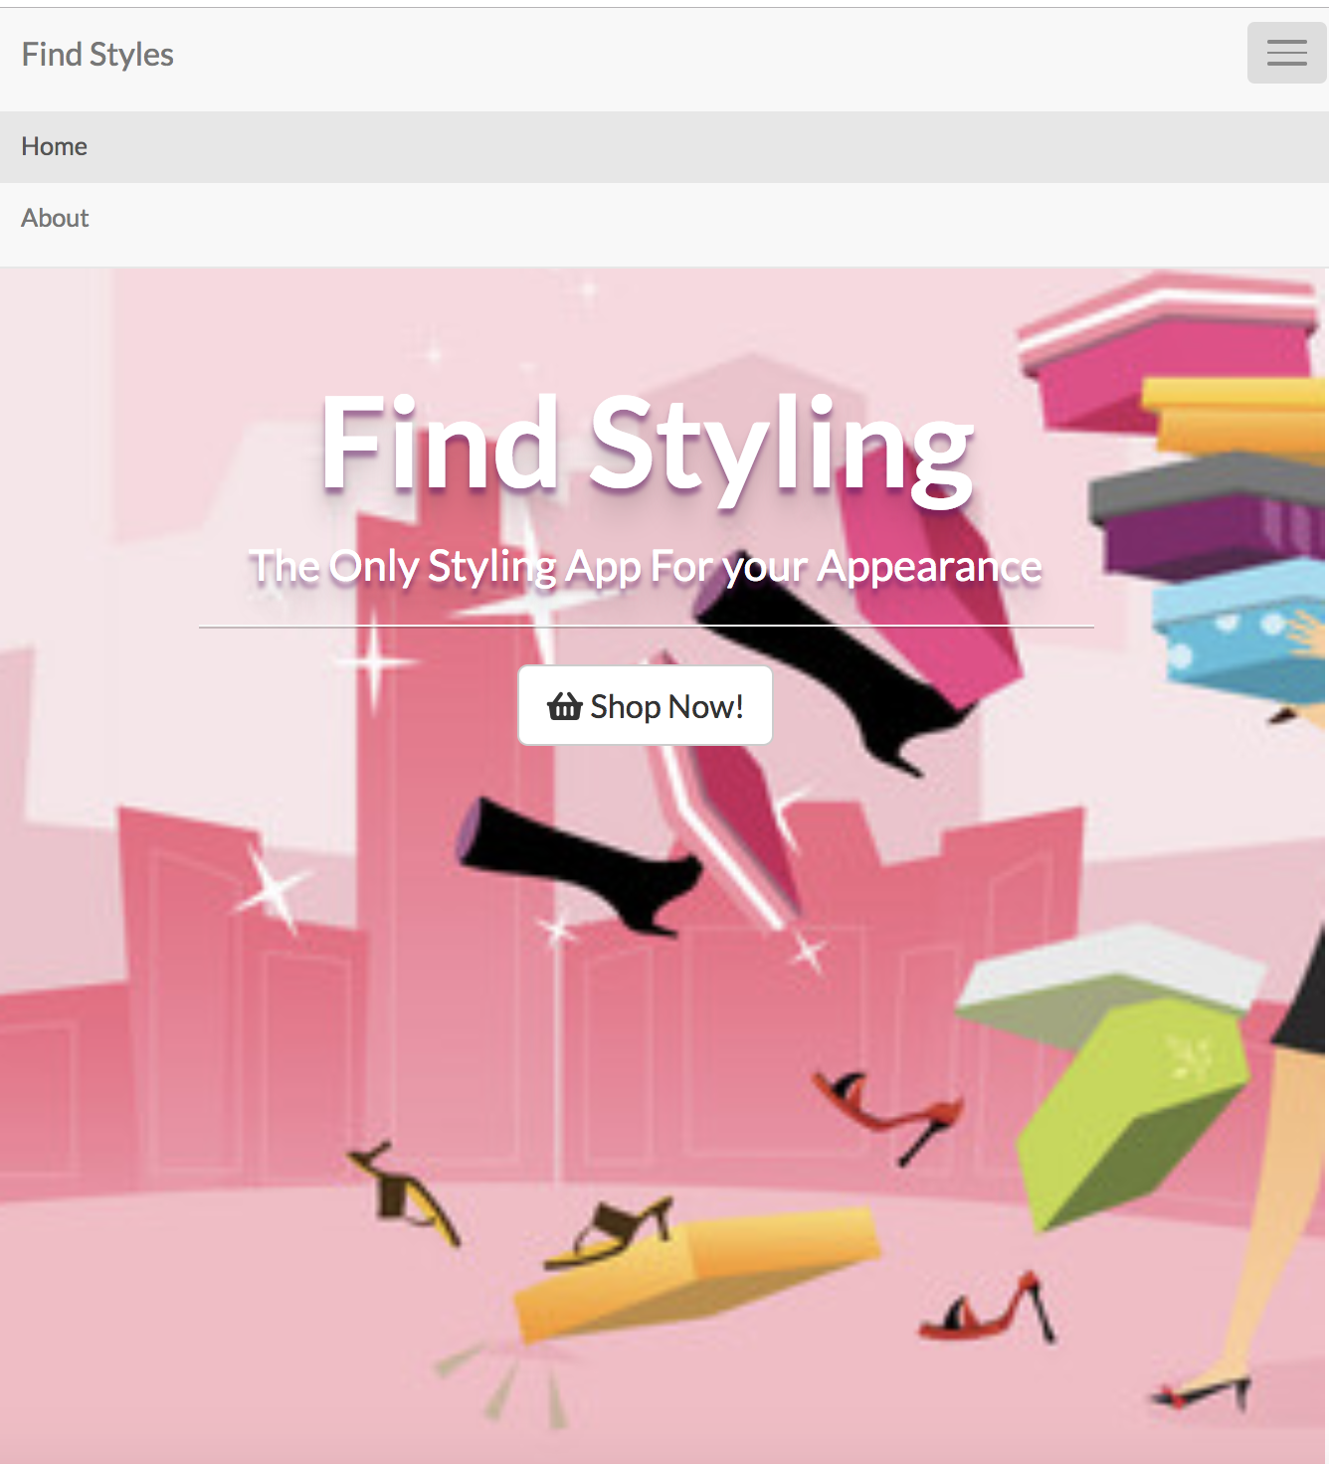

Hamburger

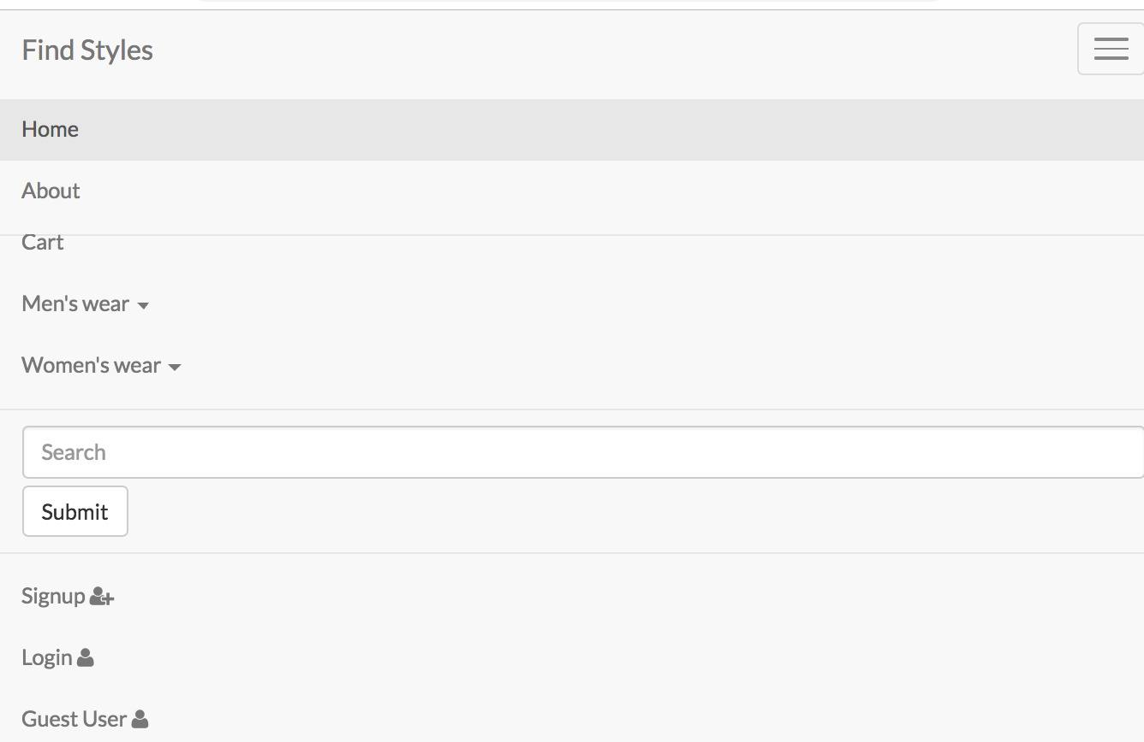

Men’s section:

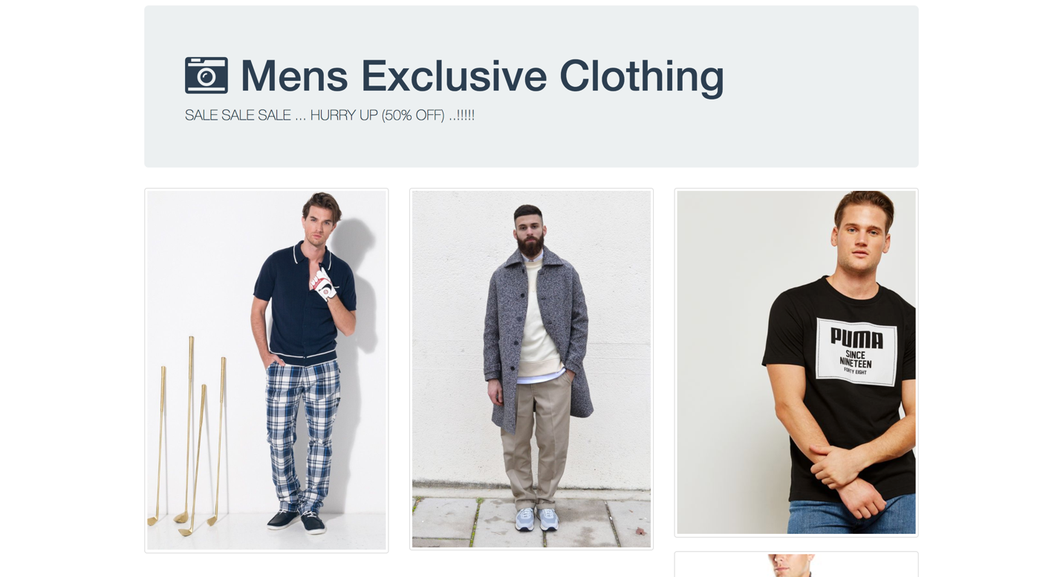

Women’s Section:

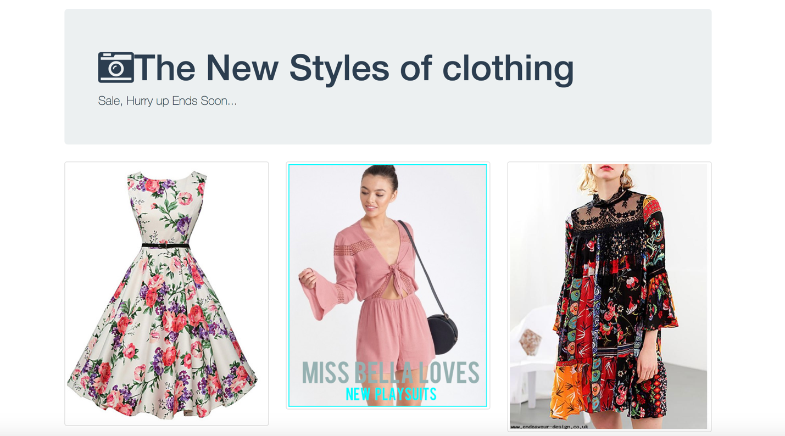

Login:

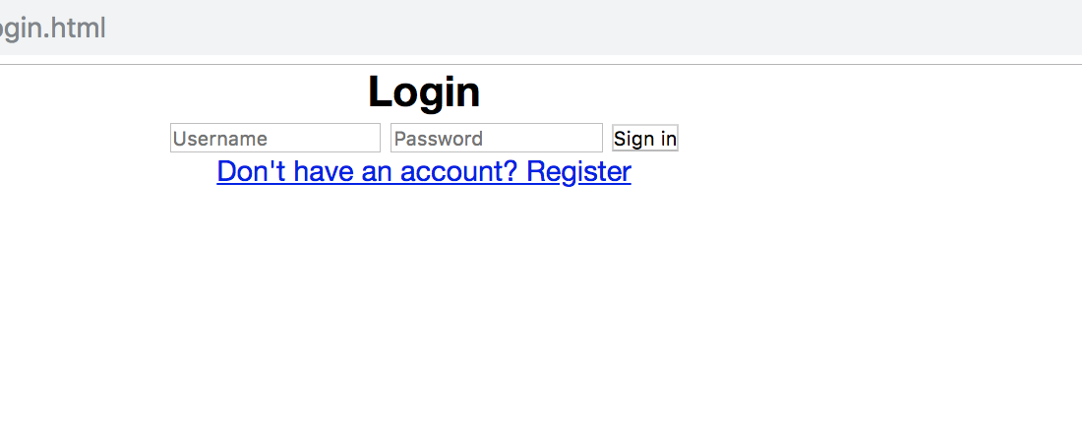

Sign Up :

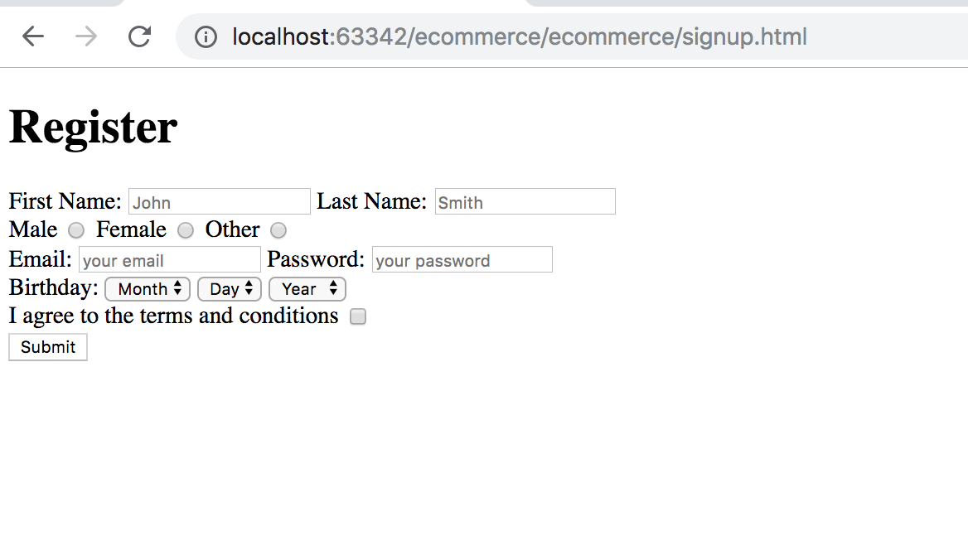

Cart:

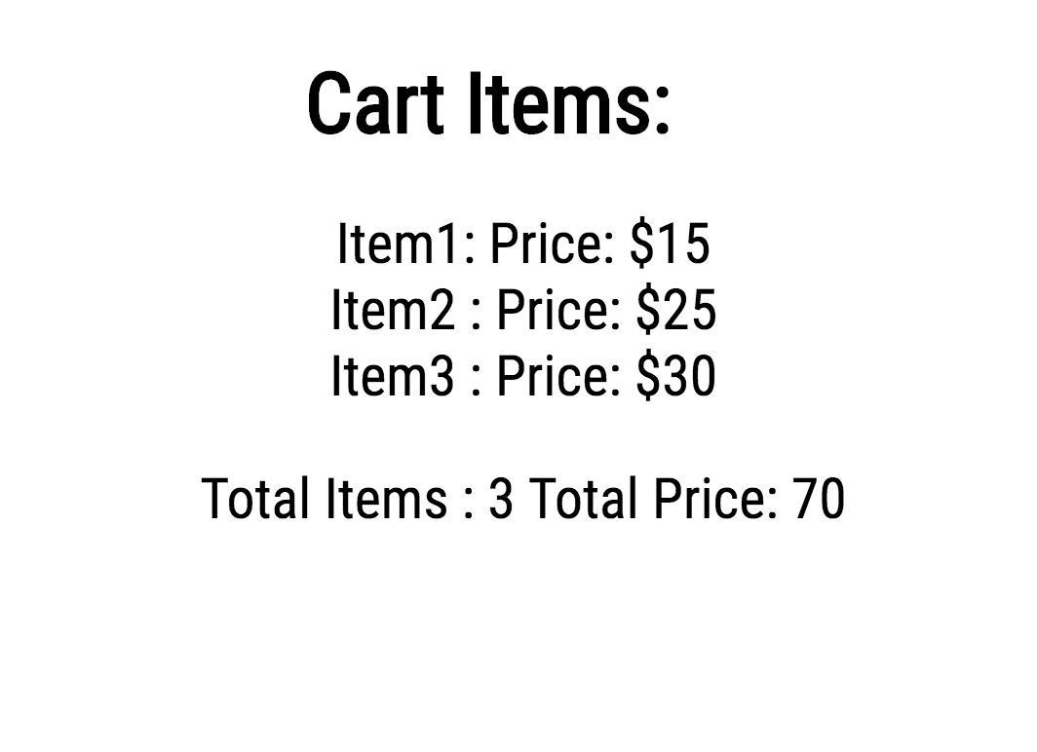

Product Details and Description:

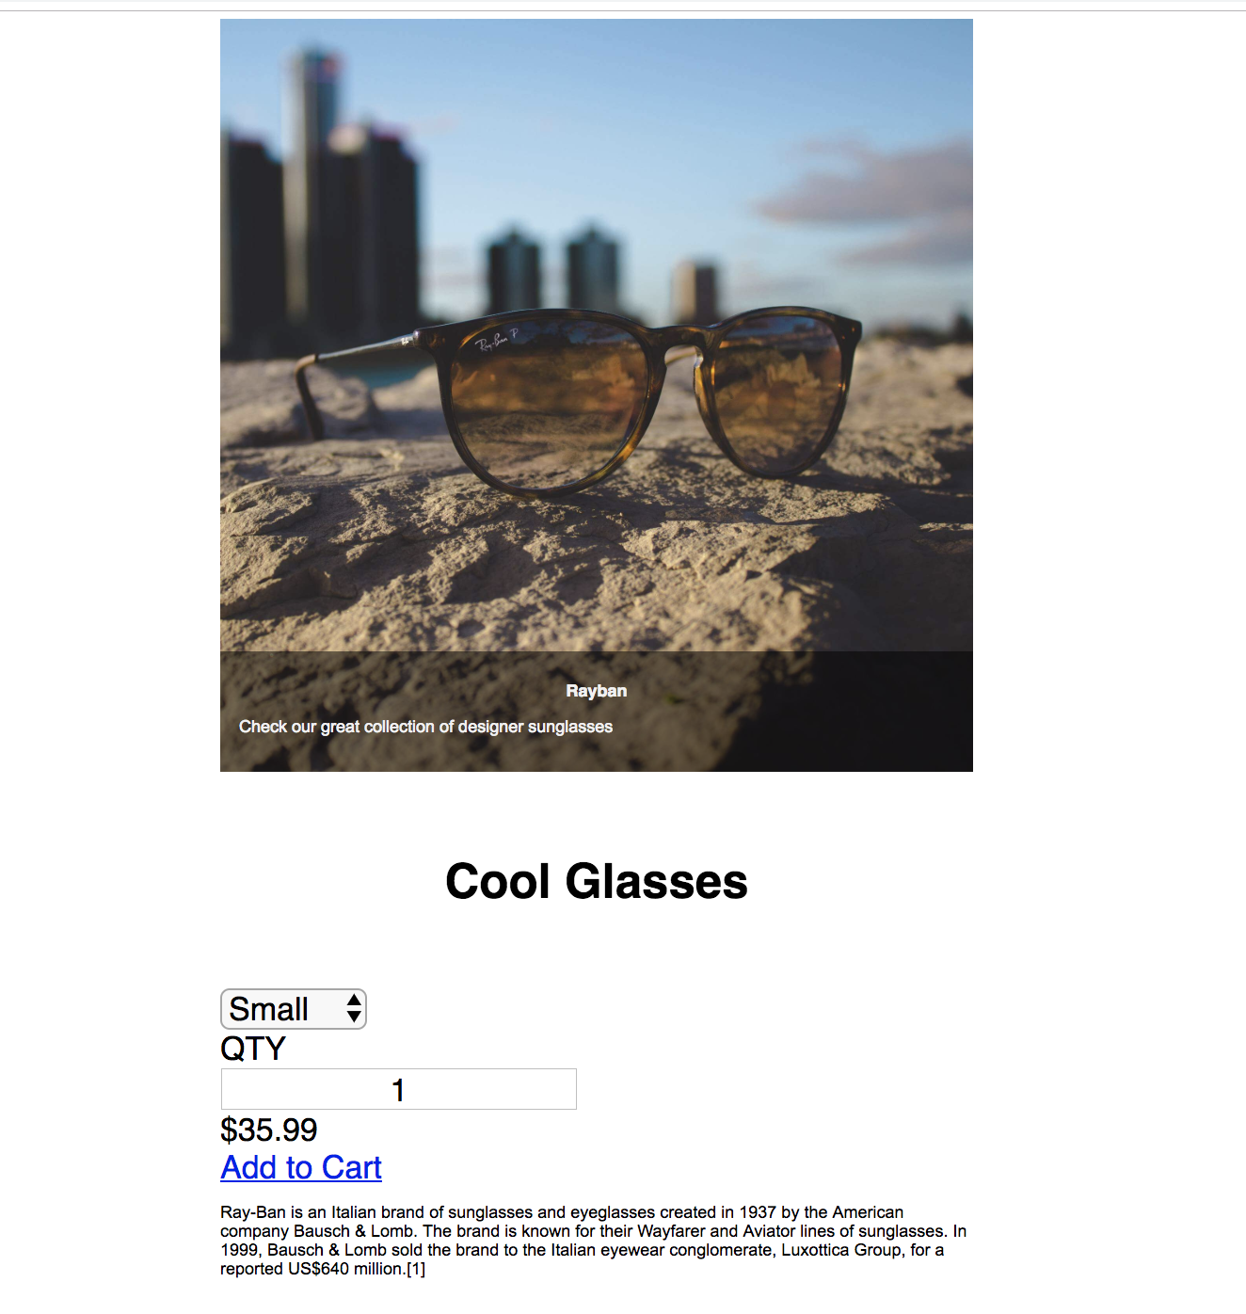

Images are Responsive to the window size:

Normal Size:

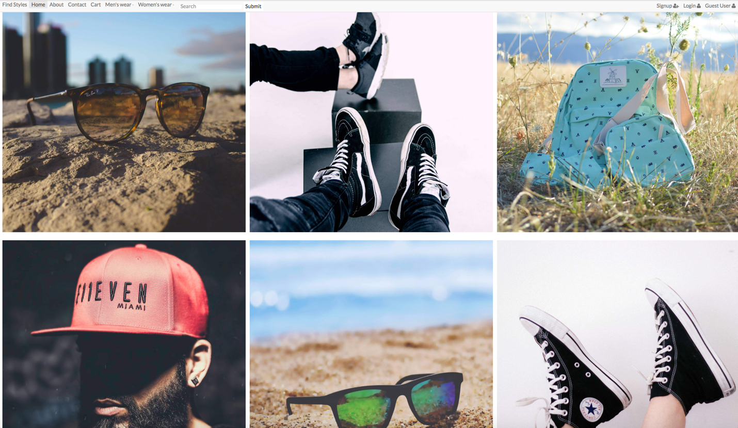

Half Window size:

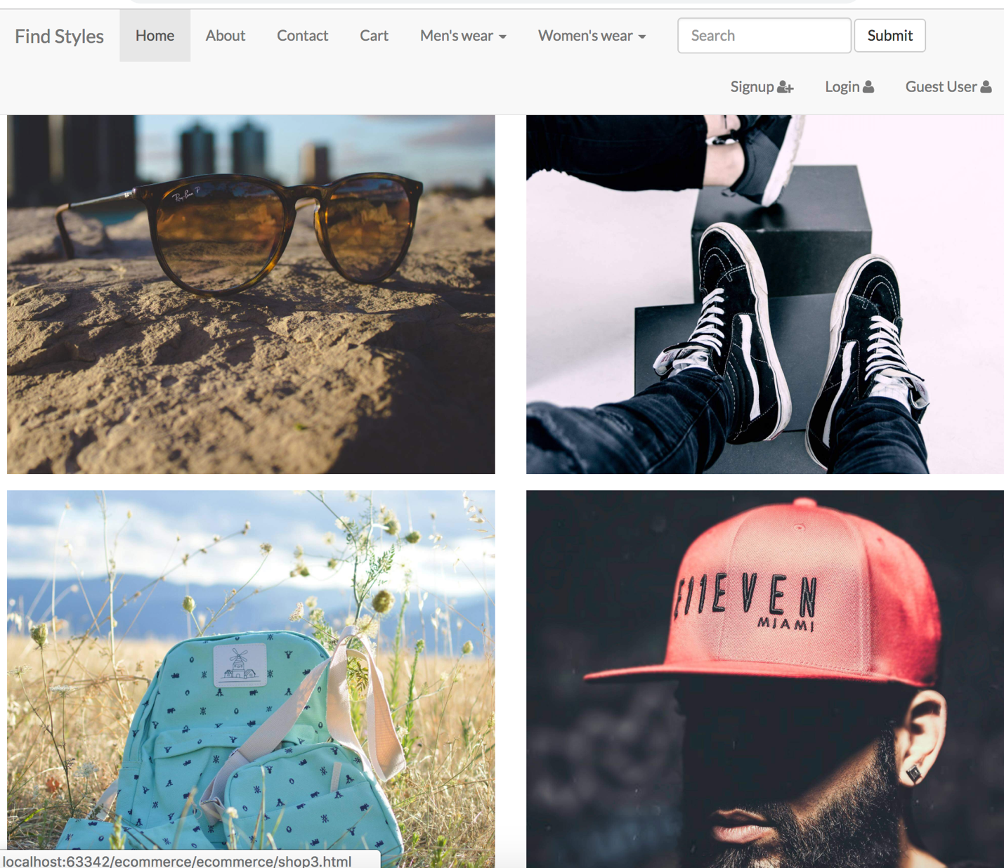

Mobile Size:

